AWS Secrets Manager
Introduction
Amazon Web Services Secrets Manager is a fully managed AWS service used to securely store, manage, and retrieve sensitive information such as:
- Database passwords
- API keys
- Tokens
- Application credentials
It helps improve application security by protecting confidential data.
What is a Secret?
A secret is sensitive information used by applications.
Examples:
- Database username/password
- API keys
- Access tokens
- SSH credentials

Purpose of AWS Secrets Manager
AWS Secrets Manager is used to:
- Securely store secrets
- Rotate credentials automatically
- Control secret access
- Improve security
- Avoid hardcoding passwords in applications

Features of AWS Secrets Manager
1. Secure Storage
Stores secrets securely using encryption.

2. Automatic Rotation
Automatically changes passwords and credentials.

3. Fine-Grained Access Control
Uses IAM policies to control access.

4. Integration with AWS Services
Works with:
- RDS
- Lambda
- EC2
- ECS
- Redshift

5. Audit and Monitoring
Integrated with:
- CloudTrail
- CloudWatch

How AWS Secrets Manager Works
Workflow
Application → Secrets Manager → Secret Retrieval
Explanation
- Secret stored in Secrets Manager
- Application requests secret
- Secrets Manager returns encrypted secret securely

AWS Secrets Manager Architecture
Application → IAM Authentication → Secrets Manager → Encrypted Secret

Advantages of Secrets Manager
- Improved security
- Automatic credential rotation
- Centralized secret management
- Reduced hardcoded passwords
- Secure AWS integration

AWS Services Integrated with Secrets Manager
- RDS
- Lambda
- EC2
- ECS
- EKS
- API Gateway

Security Features
- KMS Encryption
- IAM Access Control
- CloudTrail Logging
- Resource Policies
- Rotation Support

Real-Time Use Case
Database Password Management
Application → Secrets Manager → Database Credentials
Explanation
Instead of storing passwords inside application code, credentials are securely stored in Secrets Manager.

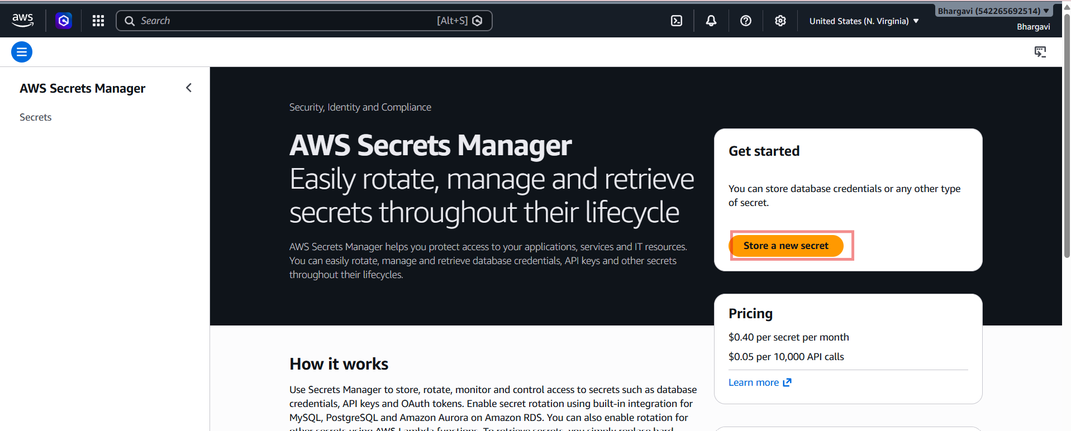
Available Secret Types
1. Credentials for Amazon RDS Database
Used for database username and password.
2. Credentials for Redshift Cluster
Used for Redshift database access.
3. Credentials for DocumentDB Database
Used for MongoDB-compatible databases.
4. Credentials for Other Databases
Used for external databases.
5. Other Type of Secret
Used for:
- API keys
- Tokens
- Custom username/password
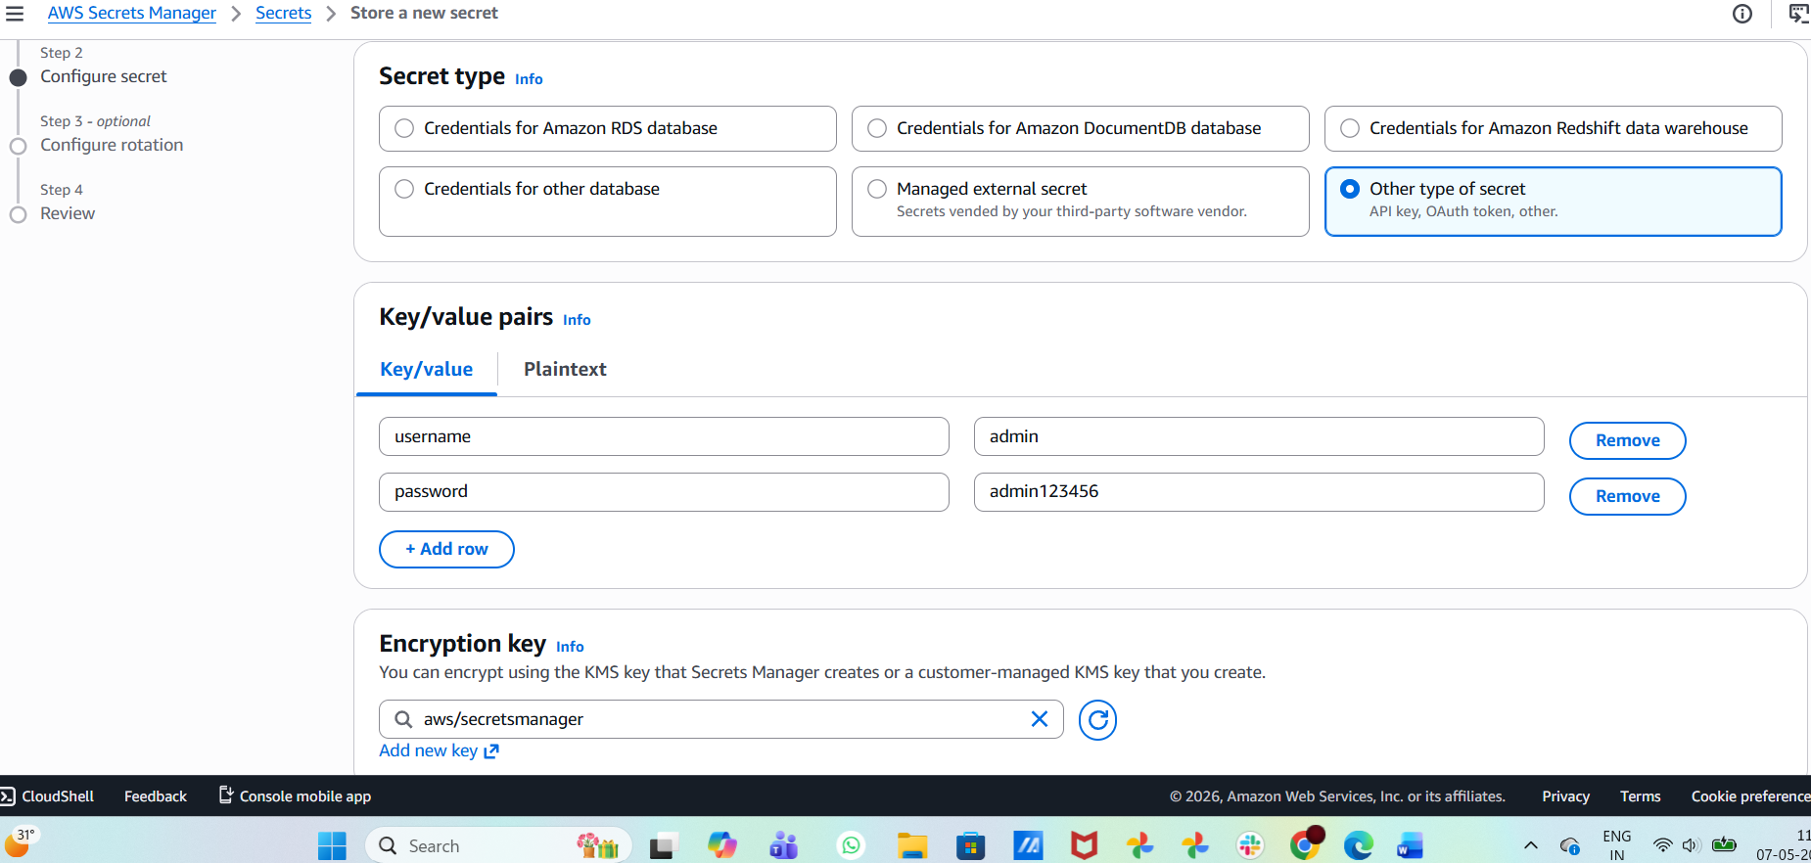
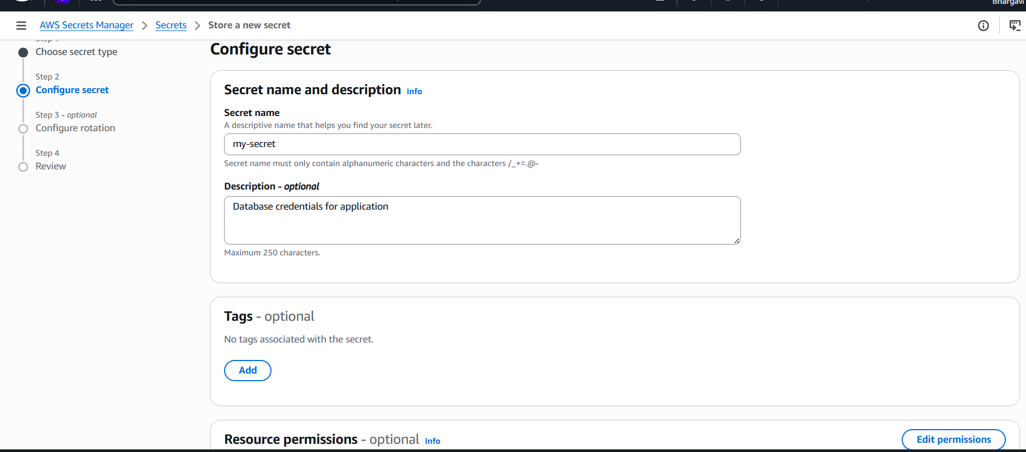
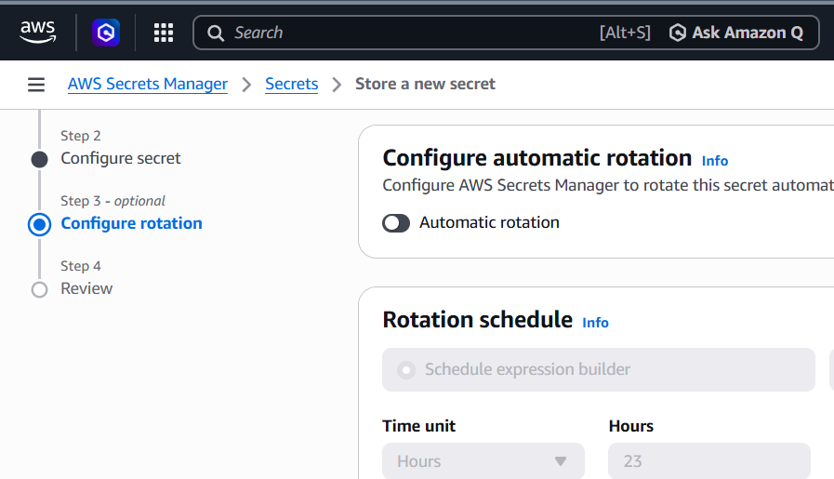
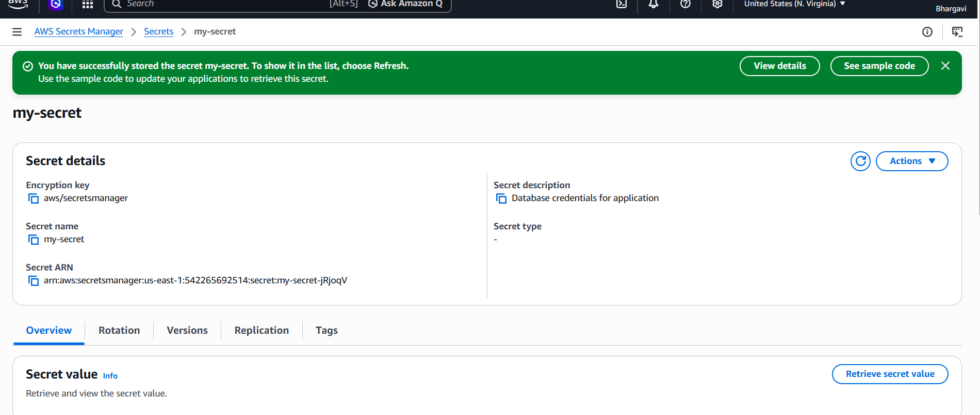
Retrieve Secret Value

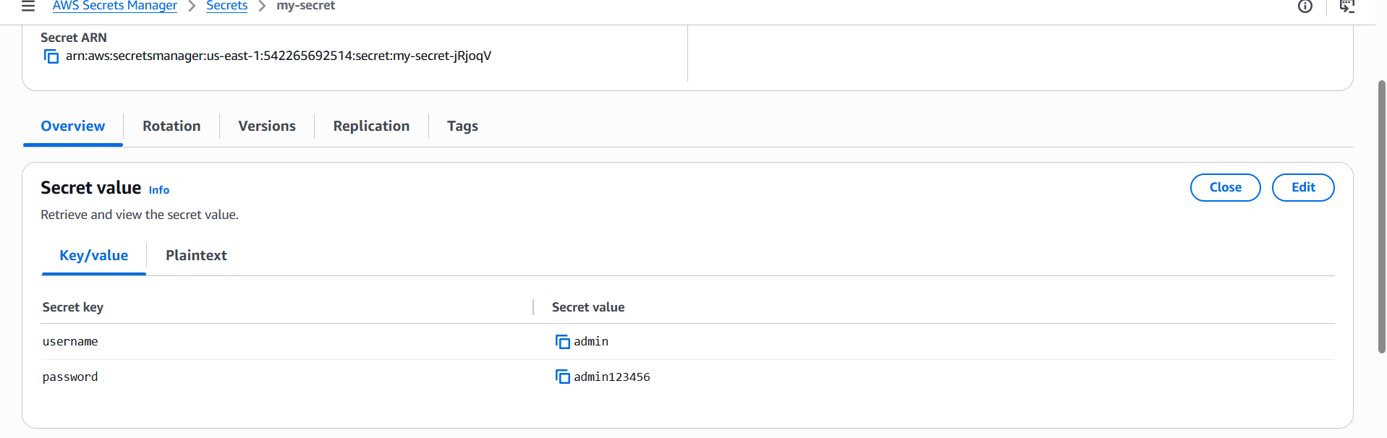
Usage > By AWS Resource
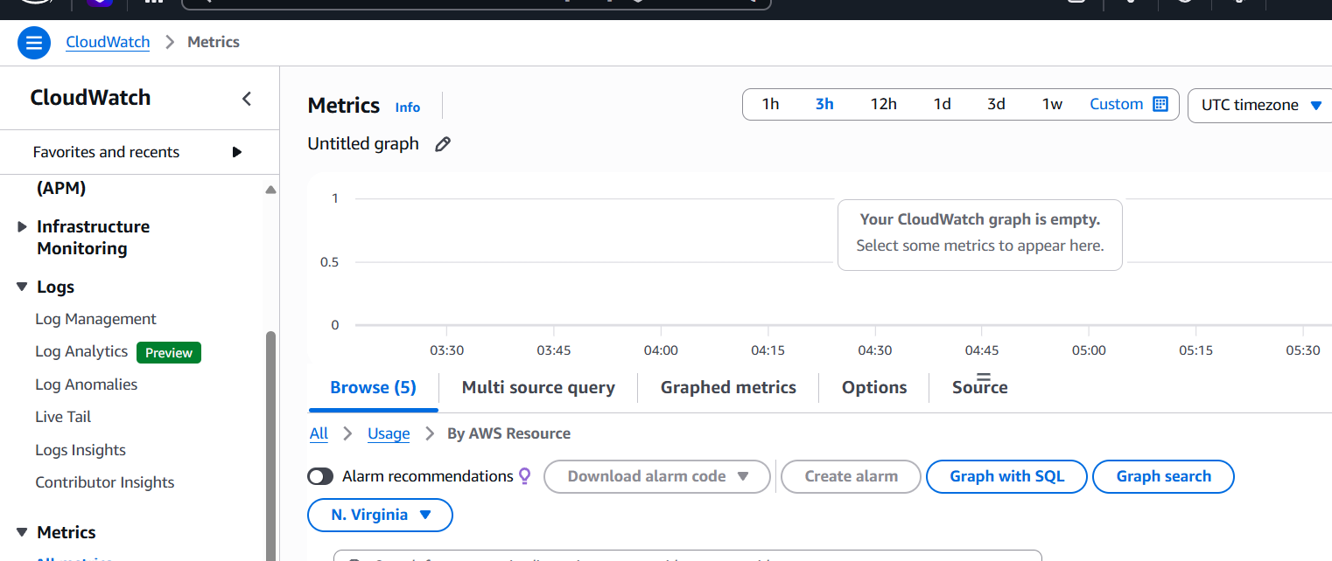
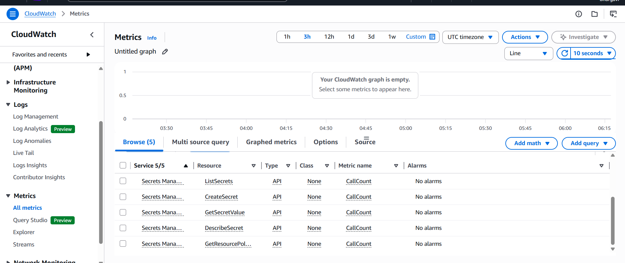
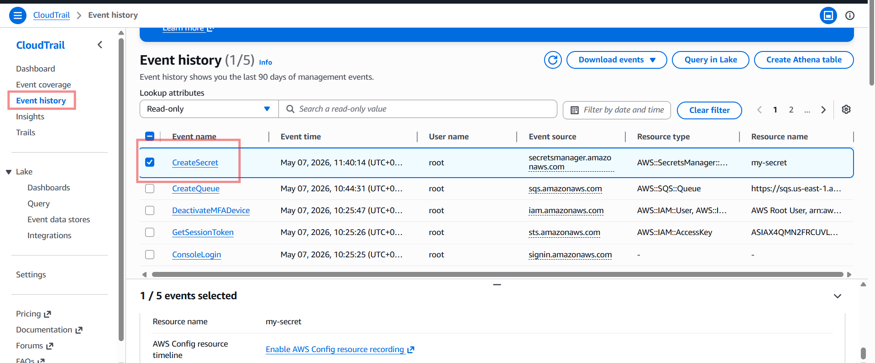
Monitoring in AWS Secrets Manager
AWS Secrets Manager activities can be monitored using AWS CloudTrail and Amazon CloudWatch. CloudTrail records events such as secret creation, retrieval, and deletion, helping administrators track access and security activities.

